

Semester Two Examination, 2018

Question/Answer booklet

MATHEMATICS

SOLUTIONS
SPECIALIST
UNITS 1 AND 2

Section Two:

Calculator-assumed

Student number: In figures

In words

Your name

Time allowed for this section
Reading time before commencing work: ten minutes
Working time: one hundred minutes

Materials required/recommended for this section
To be provided by the supervisor
This Question/Answer booklet
Formula sheet (retained from Section One)

To be provided by the candidate
Standard items: pens (blue/black preferred), pencils (including coloured), sharpener,
correction fluid/tape, eraser, ruler, highlighters

Special items: drawing instruments, templates, notes on two unfolded sheets of A4 paper, and up to three calculators approved for use in this examination

Important note to candidates
No other items may be taken into the examination room. It is your responsibility to ensure that you do not have any unauthorised material. If you have any unauthorised material with you, hand it to the supervisor before reading any further.

Structure of this paper

Section | Number of questions available | Number of questions to be answered | Working  time (minutes) | Marks available | Percentage of examination
Section One:  Calculator-free | 8 | 8 | 50 | 52 | 35
Section Two:  Calculator-assumed | 13 | 13 | 100 | 98 | 65
 |  |  |  | Total | 100

Instructions to candidates

1. The rules for the conduct of examinations are detailed in the school handbook. Sitting this examination implies that you agree to abide by these rules.

2. Write your answers in this Question/Answer booklet.

3. You must be careful to confine your response to the specific question asked and to follow any instructions that are specified to a particular question.

4. Supplementary pages for the use of planning/continuing your answer to a question
have been provided at the end of this Question/Answer booklet. If you use these pages to continue an answer, indicate at the original answer where the answer is continued, i.e. give the page number.

5. Show all your working clearly. Your working should be in sufficient detail to allow your answers to be checked readily and for marks to be awarded for reasoning. Incorrect answers given without supporting reasoning cannot be allocated any marks. For any question or part question worth more than two marks, valid working or justification is required to receive full marks. If you repeat any question, ensure that you cancel the answer you do not wish to have marked.

6. It is recommended that you do not use pencil, except in diagrams.

7. The Formula sheet is not to be handed in with your Question/Answer booklet.

Section Two: Calculator-assumed 65% (98 Marks)
This section has thirteen (13) questions. Answer all questions. Write your answers in the spaces provided.

Working time: 100 minutes.

Question 9 (7 marks)
(a) Given that $\begin{matrix}20×19×18 \\ \overline{19×18×17×16}\end{matrix}=\begin{matrix} ^{a}P_{b} \\ \overline{ ^{c}P_{4}}\end{matrix}$, determine the values of $a, b$ and $c$. (3 marks)
Solution
$$\frac{20×19×18}{19×18×17×16}=\frac{20!}{19!}×\frac{15!}{17!}=\frac{20!}{17!}×\frac{15!}{19!}$$

$$\frac{20!}{17!}= ^{20}P_{3}, \frac{19!}{15!}= ^{19}P_{4}$$

$$a=20, b=3, c=19$$

Specific behaviours
expresses fraction with factorials
expresses as permutations
✓ lists all values

(b) Determine how many integers between $1$ and $100$ inclusive are divisible by $2$, $3$ or $13$.
(4 marks)
Solution
$$\left\lfloor 100÷2\right\rfloor +\left\lfloor 100÷3\right\rfloor +\left\lfloor 100÷13\right\rfloor =50+33+7=90$$

$$\left\lfloor 100÷6\right\rfloor +\left\lfloor 100÷26\right\rfloor +\left\lfloor 100÷39\right\rfloor =16+3+2=21$$

$$\left\lfloor 100÷78\right\rfloor =1$$

$$n=90-21+1=70 \text{integers}$$

Specific behaviours
correct number divisible singly
✓ correct number divisible by pairs
✓ correct number divisible by all three
✓ correct total

Question 10 (6 marks)
(a) In the circle shown below, minor arc $PR$ subtends an angle of $120°$ at $O$, the centre of the circle, and the size of angle $RPQ$ is $55°$. Determine the size of angle $POQ$. (2 marks)

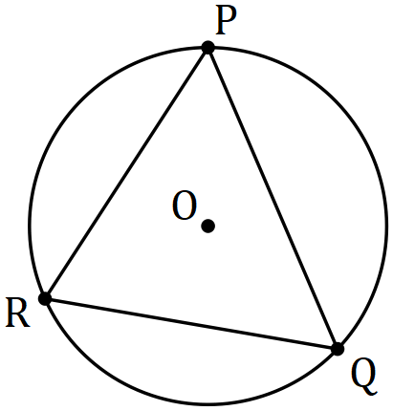
Solution
$$∠ROQ=2×55=110° \\ ∠POQ=360-110-120=130°$$

Specific behaviours
indicates size of $∠ROQ$
✓ correct $∠POR$

(b) In the diagram below, $AB$ is tangent to the circle with centre $O$ at $A$, secant $BD$ intersects the circle at $C$ and $D$, and the sizes of angles $AOC$ and $COD$ are $72°$ and $104°$ respectively. Determine the size of angle $ABC$. (4 marks)
Solution
$$∠ODC=\frac{180-104}{2}=38°$$
$$∠DOA=72+104=176°$$

$$∠OAB=90°$$

Using $OABD$:

$$∠ABC=360-38-176-90 \\ =56°$$

Specific behaviours
✓ correct $∠ODC$
✓ correct $∠DOA$
indicates $∠OABA$ is right-angle
✓ correct $∠ABC$

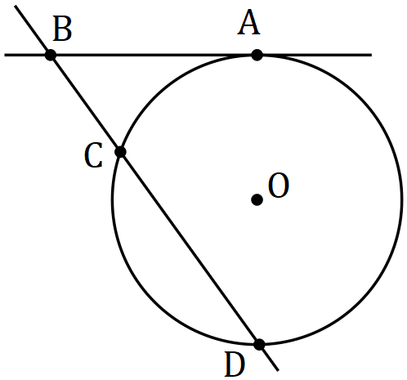

Question 11 (8 marks)
(a) Show how to express $0.\overline{23}$ as a rational number. (2 marks)
Solution
If $x=0.232323…$ then $100x=23.232323…$
Hence by subtraction $99x=23⇒x=\frac{23}{99}$, which is rational.

Specific behaviours
expresses as $x$ and $100x$
✓ uses subtraction to express as rational

(b) Prove that the sum of any three consecutive integers is always a multiple of three.
(3 marks)
Solution
Let the integers be $n, n+1, n+2$ and their sum be $S$.

$$S=n+n+1+n+2 \\ =3n+3 \\ =3(n+1)$$

Hence $S$ is always a multiple of $3$.

Specific behaviours
clearly indicates three consecutive integers
✓ creates sum
✓ factors out $3$ and makes conclusion

(c) Prove by contradiction that $\sqrt{7}$ is irrational. (3 marks)
Solution
Assume that $\sqrt{7}$ is rational and can be expressed in the form $\frac{a}{b}$, where a and b are integers with no common factor greater than $1$.

$\sqrt{7}=\frac{a}{b}⇒a^{2}=7b^{2}$, so that $a^{2}$ and hence a must be a multiple of $7$.

Since $a=7k$ (k an integer) then ${\left(7k\right)}^{2}=7b^{2}⇒{7k}^{2}=b^{2}$, so that $b^{2}$ and hence b must be a multiple of $7$.

Since a and b are both multiples of $7$, the assumption they have no common factor is contradicted and so $\sqrt{7}$ must be irrational.

Specific behaviours
makes rational assumption including bolded condition
deduces that a and $b$ must both be multiples of $7$
explains contradiction

Question 12 (8 marks)
Let vector $a=4i-6j$.

(a) Determine the angle between $a$ and $-7i-10j$. (1 mark)
Solution
Using CAS
$$θ=68.7°$$

Specific behaviours
✓ correct angle

(b) Let vector $b=14i+tj$. Determine the value of $t$ so that $a$ is

(i) parallel to $b$. (2 marks)
Solution
$$\frac{4}{14}=\frac{-6}{t}⇒t=-6×\frac{14}{4}=-21$$

Specific behaviours
indicates method
✓ correct value

(ii) perpendicular to $b$. (2 marks)
Solution
$$a∙b=0⇒\left(4\right)\left(14\right)+\left(-6\right)\left(t\right)=0$$
$$t=\frac{28}{3}=9.\overline{3}$$

Specific behaviours
indicates method
✓ correct value

(c) Determine the vector projection of $a$ on $-6i+8j$. (3 marks)
Solution
Let $c=-6i+8j$. Then $\hat{c}=-0.6i+0.8j$.

Using CAS, $\left(a∙\hat{c}\right)\hat{c}=\frac{108}{25}i-\frac{144}{25}j=4.32i-5.76j$

Specific behaviours
indicates unit vector $\hat{c}$
✓ indicates method
✓ correct projection

Question 13 (8 marks)
Two matrices are given by $P=\left[\begin{matrix}4 & 7 \\ -8 & 3\end{matrix}\right]$ and $Q=\left[\begin{matrix}3 & -7 \\ 8 & 4\end{matrix}\right]$.

(a) Determine $PQ$. (1 mark)
Solution
$$PQ=\left[\begin{matrix}68 & 0 \\ 0 & 68\end{matrix}\right]$$

Specific behaviours
correct product

(b) Given that $Q^{-1}=kP$, determine the exact value of the constant $k$. (2 marks)
Solution
$$Q^{-1}Q=kPQ⇒I=kPQ$$
$$k=\frac{1}{68}$$

Specific behaviours
uses matrix algebra or states $Q^{-1}$
✓ correct value

The system of equations $3a=7b+102$ and $8a+4b+34=0$ can be expressed as a matrix equation in the form $QX=R$.

(c) Determine matrices $X$ and $R$. (2 marks)
Solution
$$\left[\begin{matrix}3 & -7 \\ 8 & 4\end{matrix}\right]×\left[\begin{matrix}a \\ b\end{matrix}\right]=\left[\begin{matrix}102 \\ -34\end{matrix}\right]$$

$$X=\left[\begin{matrix}a \\ b\end{matrix}\right], R=\left[\begin{matrix}102 \\ -34\end{matrix}\right]$$

Specific behaviours
correct matrix $X$
✓ correct matrix $R$

(d) Express matrix $X$ in terms of matrices $P$ and $R$. (2 marks)
Solution
$$QX=R$$
$$Q^{-1}QX=Q^{-1}R$$
$$X=\frac{1}{68}PR$$

Specific behaviours
pre-multiplies by $Q^{-1}$
✓ correct expression

(e) Solve the system of equations. (1 mark)
Solution
$$a=2.5, b=-13.5$$

Specific behaviours
correct solution

Question 14 (6 marks)
A segment of a circle has a perpendicular height of $h$ and width $w$.

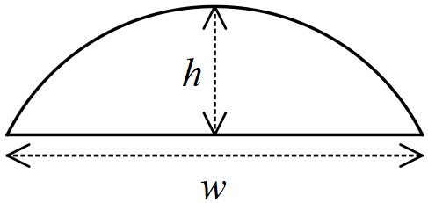

(a) Determine the radius of the arc of the segment when $h=3$ cm and $w=8$ cm. (3 marks)
Solution
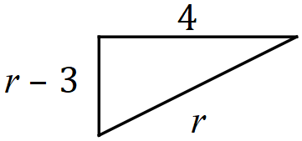
$$r^{2}={\left(r-3\right)}^{2}+4^{2}$$
$$6r=9+16$$
$$r=\frac{25}{6}=4.1\overline{6} \text{cm}$$

Specific behaviours
relevant sketch
✓ uses Pythagoras' Theorem
✓ correct radius

(b) Use the intersecting chord theorem to derive a formula for the radius of the arc of a segment of width $w$ and height $h$, where the chords are the straight edge of the segment and the diameter of the circle. (3 marks)
Solution
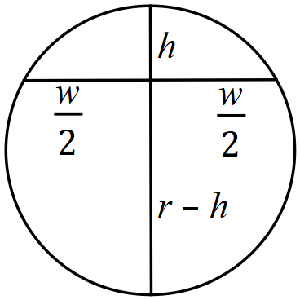
$$h\left(2r-h\right)={\left(\frac{w}{2}\right)}^{2} \\ 2rh=h^{2}+\frac{w^{2}}{4} \\ r=\frac{h}{2}+\frac{w^{2}}{8h}$$

Specific behaviours
✓ labelled sketch of intersecting chords
uses theorem to form equation
✓ correct formula

Question 15 (8 marks)
Circle $C$ has equation ${\left(x-2\right)}^{2}+{\left(y+6\right)}^{2}=16$.

(a) Circle $C$ is transformed by the matrix $M=\left[\begin{matrix}0 & 1 \\ 1 & 0\end{matrix}\right]$ to circle $C'$. Describe transformation $M$ and state the equation of circle $C'$. (3 marks)
Solution
$M$ is a reflection in the line $y=x$.

Centre: $\left[\begin{matrix}0 & 1 \\ 1 & 0\end{matrix}\right]\left[\begin{matrix}2 \\ -6\end{matrix}\right]=\left[\begin{matrix}-6 \\ 2\end{matrix}\right]$

Equation: ${\left(x+6\right)}^{2}+{\left(y-2\right)}^{2}=4^{2}=16$

Specific behaviours
states reflection with equation of line
✓ identifies new centre
✓ correct equation

(b) Circle $C'$ is then transformed by the matrix $N=\left[\begin{matrix}3 & 0 \\ 0 & 3\end{matrix}\right]$ to circle $C''$. Describe transformation $N$ and state the equation of circle $C''$. (3 marks)
Solution
$N$ is a dilation about $(0, 0)$ of scale factor $3$.

Centre: $\left[\begin{matrix}3 & 0 \\ 0 & 3\end{matrix}\right]\left[\begin{matrix}-6 \\ 2\end{matrix}\right]=\left[\begin{matrix}-18 \\ 6\end{matrix}\right]$

Equation: ${\left(x+18\right)}^{2}+{\left(y-6\right)}^{2}={\left(4×3\right)}^{2}={12}^{2}=144$

Specific behaviours
states dilation with scale factor (dilation centre not required)
✓ identifies new centre
✓ correct equation

(c) Determine the single matrix $P$ that will transform circle $C''$ back to circle $C$. (2 marks)
Solution
$${\left(NM\right)}^{-1}=\left[\begin{matrix}0 & \frac{1}{3} \\ \frac{1}{3} & 0\end{matrix}\right]$$

Specific behaviours
indicates correct method
✓ correct matrix $P$

Question 16 (11 marks)
Two forces act on a body. $F_{1}$ has a magnitude of $335$ N and acts on a bearing of $145$. $F_{2}$ has a magnitude of $295$ N and acts on a bearing of $080$.

(a) Determine

(i) the magnitude and direction of the sum of the two forces. (6 marks)
Solution
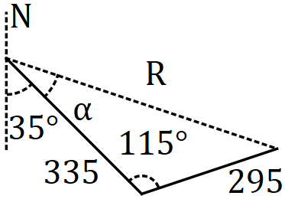

$$R^{2}={345}^{2}+{295}^{2}-2\left(345\right)\left(295\right)\cos{115}$$

$$R=531.8 \text{N}$$

$$\frac{531.8}{\sin{115}}=\frac{295}{\sin{α}}$$

$$α=30.2°$$

$$\text{Bearing}:180-35-30.2≈115$$

Specific behaviours
triangle showing sum of two forces
✓ use of cosine rule with correct angle
✓ correct magnitude
✓ indicates use of sine rule
✓ correct value of $α$
✓ correct bearing

CAS Solution
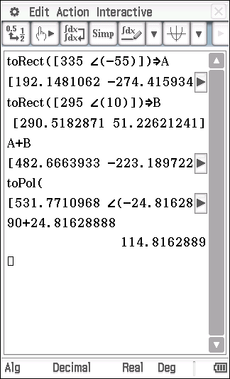
Specific behaviours
✓ correct polar angles
converts $F_{1}$ to Cartesian
converts $F_{2}$ to Cartesian
✓ adds forces
✓ converts back to polar
✓ states magnitude and bearing

(ii) the magnitude and direction of a third force that would keep the body in equilibrium. (1 mark)
Solution
$$115+180=295$$

$$F_{3}=531.8 \text{N on bearing} 295$$

Specific behaviours
correct magnitude and bearing

(b) The bearing $F_{2}$ acts on is changed so that the direction of $F_{1}+F_{2}$ is due east. Determine the new bearing of $F_{2}$. (4 marks)
Solution
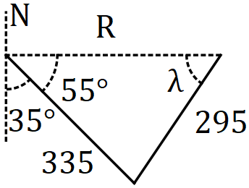

$$\frac{335}{\sin{λ}}=\frac{295}{\sin{55}}$$

$$λ=68.5° \text{or} 111.5°$$

$$\text{Bearings}:90-68.5=021.5 \\ \text{or}:360-\left(111.5-90\right)=338.5$$

Specific behaviours
diagram
✓ indicates use of sine rule
✓ correct values of $λ$
✓ both possible bearings

Question 17 (8 marks)
A small body $P$ moves in a straight line. The displacement of the body from a fixed point $O$ is given by $x=a\sin\left(b\left(t+c\right)\right)+d$, where $x$ is in centimetres, $t$ is the time in seconds. The graph of $x$ against $t$ is shown below.

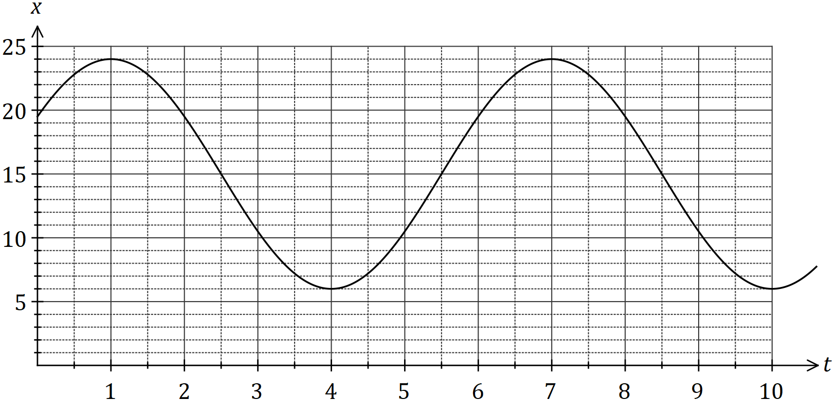

(a) Determine the values of the positive constants $a, b, c$ and $d$. (4 marks)
Solution
$$a=\left(24-6\right)÷2=9 \\ b=\frac{2π}{6}=\frac{π}{3} \\ c=\frac{1}{2} (\text{or} 6.5, 12.5, …) \\ d=24-9=15$$

Specific behaviours
each correct value

(b) Express the relationship between $x$ and $t$ as a cosine function. (2 marks)
Solution
$$c=\frac{1}{2}-\frac{1}{4}\left(6\right)=-1 (\text{or}-7, -1, 5, …) \\ x=9\cos\left(\frac{π}{3}\left(t-1\right)\right)+15$$

Specific behaviours
only changes value of $c$
✓ correct function

(c) Determine the first time that $P$ is $18$ cm from $O$ after $150$ seconds, giving your answer to two decimal places. (2 marks)
Solution
$$9\sin\left(\frac{π}{3}\left(t-\frac{1}{2}\right)\right)+15=18$$
$$t=152.18 \text{s}$$

Specific behaviours
method
✓ correct time

Question 18 (7 marks)
Let $N=\{1, 2, 3, 4, 5, 6, 7, 8\}$.

(a) Three or four-digit codes are to be formed using integers selected from $N$, such as $287$ or $1381$.

Determine the number of codes that can be formed if

(i) there are no restrictions. (2 marks)
Solution
$$8^{3}+8^{4}=512+4096 \\ =4608 \text{codes}$$

Specific behaviours
indicates number of 3- and 4-digit codes
✓ correct total

(ii) no integer may be used more than once in a code. (2 marks)
Solution
$$^{8}P_{3}+ ^{8}P_{4}=336+1680 \\ =2016 \text{codes}$$

Specific behaviours
uses permutations for 3- and 4-digit codes
✓ correct total

(b) Using the pigeon-hole principle or otherwise, prove that when five integers are selected from $N,$ at least one pair of the integers will have a sum of $9$. (3 marks)
Solution
Partition $N$ into $4$ pigeon-holes with sums of $9:$ $\left\{1, 8\right\}, \left\{2, 7\right\}, \left\{3, 6\right\}, \{4, 5\}$

If $5$ integers (pigeons) are selected from $N$ then by the pigeon-hole principle, at least $2$ must be in the same pigeon-hole.

Hence at least one pair of the integers will have a sum of $9$.

Specific behaviours
lists pigeonholes
✓ uses pigeonhole principle
✓ makes conclusion

Question 19 (8 marks)
(a) The four points $K, L, M$ and $N$ lie in that order on the circumference of a circle. Chords $KM$ and $LN$ intersect at $X$. Prove that $∆KXL\sim ∆NXM$. (4 marks)
Example solution
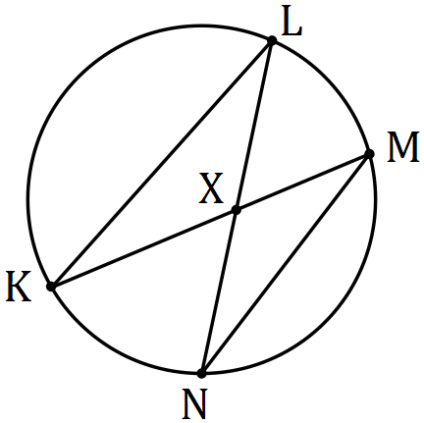 | $$∠KXL=∠NXM \text{- vertically opposite} \\ ∠KLN=∠KMN \text{- stand on same arc} \\ ∴∆KXL\sim ∆NXM \text{- AAA}$$
Specific behaviours
labelled diagram
✓ one pair of equal angles with reason
✓ second pair of equal angles with reason
✓ states similarity with reason

(b) In triangle $ABC$, $P, Q$ and $R$ are the midpoints of $AB, AC$ and $BC$ respectively. If $\vec{AB}=b$ and $\vec{AC}=c$, use a vector method to prove that $PBRQ$ is a parallelogram. (4 marks)
Example solution
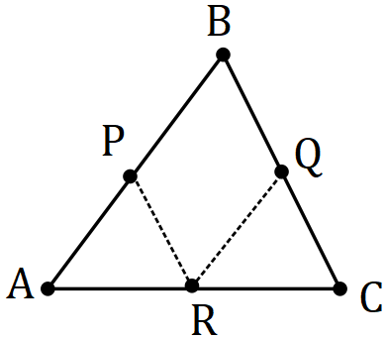 | $$\vec{PR}=\vec{PA}+\vec{AR} \\ =-\frac{1}{2}b+\frac{1}{2}c$$  $$\vec{BQ}=\frac{1}{2}\vec{BC} \\ =\frac{1}{2}\left(\vec{BA}+\vec{AC}\right) \\ =\frac{1}{2}\left(-b+c\right) \\ =-\frac{1}{2}b+\frac{1}{2}c \\ =\vec{PR}$$
Hence $PBRQ$ is a parallelogram since it has a pair of opposite sides that are parallel and equal in length.

Specific behaviours
labelled diagram
✓ derives vector for one side of parallelogram
✓ derives second vector for opposite side
✓ shows vectors are equal and makes conclusion

Question 20 (6 marks)
Use mathematical induction to prove that for all positive integers $n$

$$1×5+2×6+3×7+…+n\left(n+4\right)=\frac{n}{6}\left(n+1\right)\left(2n+13\right).$$
Solution
Let $\text{Claim}(n)$ be the statement
$$1×5+2×6+3×7+…+n\left(n+4\right)=\frac{n}{6}(n+1)(2n+13)$$

$\text{Claim}(1)$ is the statement $1×5=\frac{1}{6}\left(2\right)(15)$ and so $\text{Claim}(1)$ is shown to be true.

Assume $\text{Claim}(k)$ is true so that
$$1×5+2×6+3×7+…+k\left(k+4\right)=\frac{k}{6}(k+1)(2k+13)$$

$$LHS \text{of} \text{Claim}\left(k+1\right)=1×5+2×6+…+k\left(k+4\right)+\left(k+1\right)\left(k+1+4\right) \\ =\frac{k}{6}\left(k+1\right)\left(2k+13\right)+\left(k+1\right)\left(k+1+4\right) \text{using Claim}(k) \\ =\frac{k+1}{6}\left(2k^{2}+13k+6k+30\right) \\ =\frac{k+1}{6}\left(k+2\right)\left(2k+15\right) \\ =RHS \text{of} \text{Claim}\left(k+1\right)$$

We have shown that $\text{Claim}(1)$ is true and that $\text{Claim}\left(k\right)⇒\text{Claim}(k+1)$ and so by the principle of mathematical induction it follows that $\text{Claim(n)}$ is true.

Specific behaviours
shows truth of initial case
✓ clearly states assumption
✓ adds $k+1$ term to statement, using $\text{Claim}(k)$
✓ factors out $\left(k+1\right)$
✓ completes factorisation
✓ closing statement

Question 21 (7 marks)
A small drone is to fly in a straight line and at a constant altitude from $P$ to $Q$. $Q$ lies $775$ m away from $P$ on a bearing of $165°$ and a steady wind of $6.6$ ms⁻¹ is blowing in the area from due east.

If the speed of the drone is set to $14.5$ ms⁻¹, determine the bearing it should steer and the time that it will take to reach $Q$.
Solution
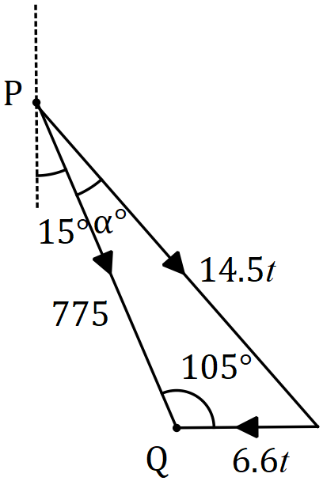

$$\frac{\sin{105}}{14.5t}=\frac{\sin{α}}{6.6t}$$

$$α=26.1°$$

$$180-105-26.1=48.9°$$

$$\frac{\sin{105}}{14.5t}=\frac{\sin{48.9}}{775}$$

$$t=68.5 \text{seconds}$$

$$\text{Bearing: }165-26.1=138.9°$$

Specific behaviours
diagram with key elements
angle between wind and $PQ$
equation using sin rule for $α$
solves for $α$
equation using sin rule for $t$
correct time
correct bearing

Supplementary page

Question number: _________

Supplementary page

Question number: _________

Supplementary page

Question number: _________

© 2018 WA Exam Papers. Carmel School has a non-exclusive licence to copy and communicate this document for non-commercial, educational use within the school. No other copying, communication or use is permitted without the express written permission of WA Exam Papers. SN014-121-4.

